**Warehouse Management System**

Software Requirements Specifications

Version 1.0

3/25/2024



F.com

**Revision History**

|  |  |  |  |
| --- | --- | --- | --- |
| Date | Version | Description | Author |
| 3/25 | 1.0 | Original | Mhd Fael and Mhd Alkhuzanie |
|  |  |  |  |
|  |  |  |  |
|  |  |  |  |
|  |  |  |  |

**Table of Contents**

**1.**  **Introduction** 4

**1.1** **Purpose** 4

**1.2** **Project Scope** 4

**2.** **Overall Description** 5

**2.1** **Description (Product Perspective)** 5

**2.2** **User Class** 6

**2.3** **Operating Environment** 7

**2.4** **Designing and Implementation Constraints** 7

**2.5** **Assumption** 7

**2.6** **Dependencies** 7

**3.** **Functions** 8

**3.1** **Functional Requirements** 8

**3.2** **None-Functional Requirements** 9

**1. Introduction**

**1.1 Purpose**

This software requirements specifications outlines functional and non-functional requirement for release 1.0 of the Warehouse Management System this document is to be used by the members of the development team and any other stakeholders who may be involved in any verifying the correct functionality of the software. Currently, all requirements specified in this document are expected for release 1.0.

**1.2 Project Scope**

A powerful digital warehouse management system is essential for any business operating with available inventory - it can help save money and acquire new efficiencies in many areas. The top five advantages of a warehouse management system are: Improved operational efficiency: Warehouse management systems automate and streamline warehouse operations from inbound receiving to outbound delivery - to enhance efficiency, streamline operations, and handle larger volumes smoothly.

**2. Overall Description**

**2.1 Description (Product Perspective)**

The supply chain is the sequence of processes through which product moves from its origin toward the customer.

The supply chaining consists of:

• Inbound logistics is the way materials and other goods are brought into

a company.

This process includes the steps to order, receive, store,

transport and manage incoming supplies.

• Outbound logistics focuses on the demand side of the supply-demand

equation. The process involves storing and moving goods to the customer or end user. The steps include order fulfillment, packing, shipping, delivery and customer service related to delivery.

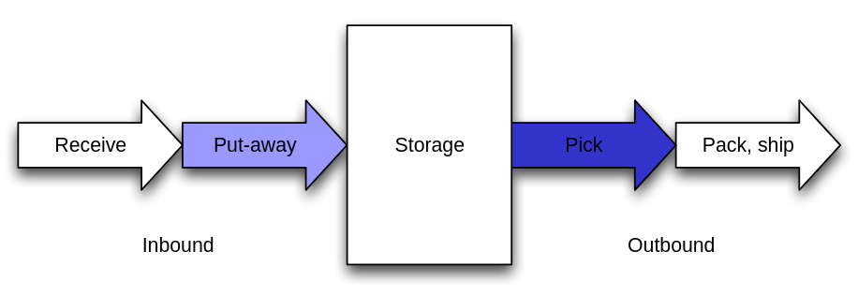

**2.2 User Class**

|  |  |
| --- | --- |
| **User** | **Description** |
| General manager | The General Manager of the warehouse is the top administrative figure of the warehouse establishment. They are the executive responsible for managing the overall operations of the company, including strategic planning, staff management, cost control, organization, and supervision of the warehouse structure. The General Manager assumes daily responsibility for warehouse operations, ensuring consistent processing of incoming and outgoing stocks according to their schedule |
| Warehouse keeper | The warehouse keeper is responsible for managing and organizing the warehouse, storage, and internal and external movement of various materials and inventory. They also track costs and quality, conduct continuous and periodic inventory checks, and regularly provide inventory, incoming, and outgoing reports. The warehouse keeper bears full responsibility for the performance and organization of the warehouse. |
| Goods receiving employee | The employee responsible for entering the goods |
| Shipping employee | The employee responsible for shipping the goods |

**2.3 Operating Environment**

* The website must operate correctly with the most updated of the following web browser:
* Google chrome
* Safari
* Firefox
* Microsoft Edge
* etc.…
* The website must be optimized for desktop as ell as smartphones and tablets
* The mobile application must run in Android and IOS

**2.4 Designing and Implementation Constraints**

* The system must pull warehouses information continuously from warehouses keepers.
* The website and mobile app should have the same colors, fonts and logos

**2.5 Assumption**

* Website will be available 24-7 outside of scheduled maintenance.

**2.6 Dependencies**

* All applicable forms will need to be transitioned to online format

**3. Functions**

**3.1 Functional Requirements**

* + 1. Account creation for managers, warehouse supervisor, shipping and receiving employees.
    2. Multiple branch management (additional services, deletion, full inquiry).
    3. Equipment management and costs (additional services, deletion, full inquiry).
    4. Inventory and item management (additional services, deletion, full inquiry).
    5. Oversight of the warehouse organizational structure and storage departments (addition or deletion of departments).
    6. Management of incoming and outgoing orders to and from the warehouse.
    7. Employee management (addition or deletion of employees, full inquiry into details).
    8. Management of order shipment information (addition, deletion, inquiry).
    9. Management of information about suppliers and manufacturers of stored materials (addition, deletion, inquiry).
    10. Monthly financial reports for all branches.
    11. Various statistics pertaining to all warehouse information and activities.

**3.2 None-Functional Requirements**

* + 1. **Performance:**

The application is fast and responsive, allowing users to access information quickly and without delay.

* + 1. **Useability:**

Design an interface for the system that is easy to use, allowing for easy navigation between system pages and the selection of suitable and pleasing colors for the eyes.

* + 1. **Reliability:**

The application operates correctly and continuously without errors.

* + 1. **Maintainability:**

The application is easy to maintain and update because the code is well-organized and dynamic, with comments suggesting the functionality of each part of the code.

* + 1. **Scalability:**

The application is scalable, capable of accommodating increasing numbers of users, features, and data without affecting performance.

* + 1. **Compatibility:**

The application is compatible with various devices and browsers to ensure accessibility for all users.

To be continued…